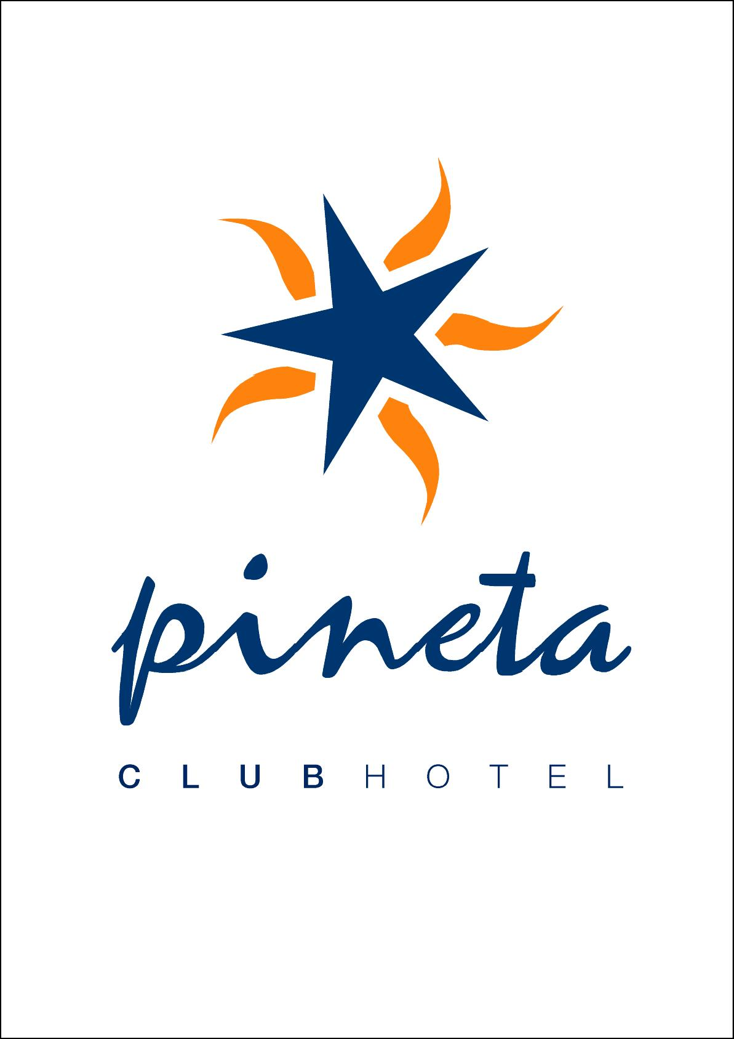

A L L I N C L U S I V E 2017

- THE FOLLOWING WILL BE PROVIDED FOR ALL INCLUSIVE GUESTS AS INDICATED BELOW;

ALL INCLUSIVE SERVICE:
- ALL INCLUSIVE SERVICE IS AVAILABLE 10:00 - 23:50 WITHIN THE TERMS OF ALL INCLUSIVE.
LOCAL ALCOHOLIC DRINKS WITHIN THE TERMS OF ALL INCLUSIVE CONSIST OF VODKA,
GIN, RAKI, DRAUGHT BEER AND DRAUGHT WINE.
SOFT DRINKS CONSIST OF : CONCENTRATED DRINKS, COLA, FANTA, SPRITE, TEA, INSTANT & FILTER
COFFEE, MILK, SODA (MINERAL WATER) AND WATER ( OPEN SERVICE /BOTTLES OF WATER ARE
CHARGEABLE).
SUNDOWNER SUITE : 10:00 – 23:50 SELF SERVICE
PINETA CAFE BAR & PATISSERIE : 10:00 – 23:50 SELF SERVICE

MAIN RESTAURANT / SELF SERVICE :
- BREAKFAST 07:30 - 10:00 OPEN BUFFET SELF SERVICE
- LUNCH 12:00 - 13:30 OPEN BUFFET SELF SERVICE
- DINNER 19:00 - 21:00 OPEN BUFFET SELF SERVICE
ANY CHANGES TO SERVICE LOCATION OR MEAL TIMES WILL BE ANNOUNCED ACCORDINGLY

SNACK SERVICE / SELF SERVICE ( SUNDOWNER SUITE ) :
ANY CHANGES TO LOCATION WILL BE ANNOUNCED ACCORDINGLY.
14:00 – 16 :00 OPEN BUFFET SELF SERVICE
    - A SELECTİON FROM THE FOLLOWING :
HAMBURGERS, CHEESEBURGERS, FISH FINGERS, MINI MEAT BALLS, MIXED PIZZA, MUSHROOM PIZZA,
MARGARITA PIZZA, TURKISH STYLE PIZZA, SPAGHETTI, PASTA, BAKED POTATOES, SAUSAGES,
MIXED VEGETABLES, FRENCH FRIES & SALAD BAR ( TOMATO, CUCUMBER, LETTUCE, CHEESE
SALAD, RED AND WHITE CABBAGE, GRATED CARROT, FISH SALAD, SEASONAL SALAD, ROCKET
LEAVES AND PARSLEY.).
- EVERY DAY THERE WILL BE A CHOICE OF 3 SNACKS FROM THE ABOVE AS WELL AS THE SALAD BAR.
THE ABOVE SNACK SERVICE WILL BE PROVIDED ALONG WITH THE ALL INCLUSIVE DRINKS SERVICE

COFFE BREAK / SELF SERVICE ( PINETA CAFE BAR & PATISSERIE) :
ANY CHANGES TO THE SERVICE DETAILS WILL BE ANNOUNCED ACCORDINGLY.
- COFFEE BREAK SERVICE 17:00 – 18 :00 OPEN BUFFET SELF SERVICE

FREQUENCY ANIMATION ( WEATHER PERMITTING ):
OFFERING SELF SERVICE SOFT DRINKS 21:00 – 23:30 WITHIN THE TERMS OF ALL INCLUSIVE.

*** ONE BRACELET IS GIVEN PER PERSON TO USE THE ALL INCLUSIVE FACILITIES. ALL INCLUSIVE SERVICE IS NOT AVAILABLE FOR GUESTS WHO DO NOT HAVE A BRACELET. SHOULD YOU LET A THIRD PARTY USE ANY ON YOUR ALL INCLUSIVE FACILITIES YOU WILL BE CHARGED 50% OF YOUR PREVIOUS
( FREE ) EXPENSES.
*** DAMAGE / LOSS TO HOTEL PROPERTY IS CHARGEABLE AND WILL AUTOMATICALLY BE BILLED TO
YOUR ROOM.

*** PLEASE LEAVE THE HOTEL, BRACELET, ROOM KEY AND RENTED SAFE KEY AT
RECEPTION ON THE DAY OF YOUR DEPARTURE.
*** PAPER OR PLASTIC GLASSES ARE USED AT THE POOL SIDE FOR HEALTH AND SAFETY REASONS.
PINETA TURKISH BATH ( WITHOUT SCRUB ),SAUNA & FITNESS CENTRE :
TURKISH BATH & SAUNA AVAILABLE 14:00 – 18:00, FITNESS CENTRE AVAILABLE 10:00 – 18:00 WITHIN THE
TERMS OF ALL INCLUSIVE

IMPORTANT NOTE : ANY SERVICES NOT LISTED ABOVE ARE CHARGEABLE
WE DO NOT SERVE ALCOHOL TO UNDER 18s

