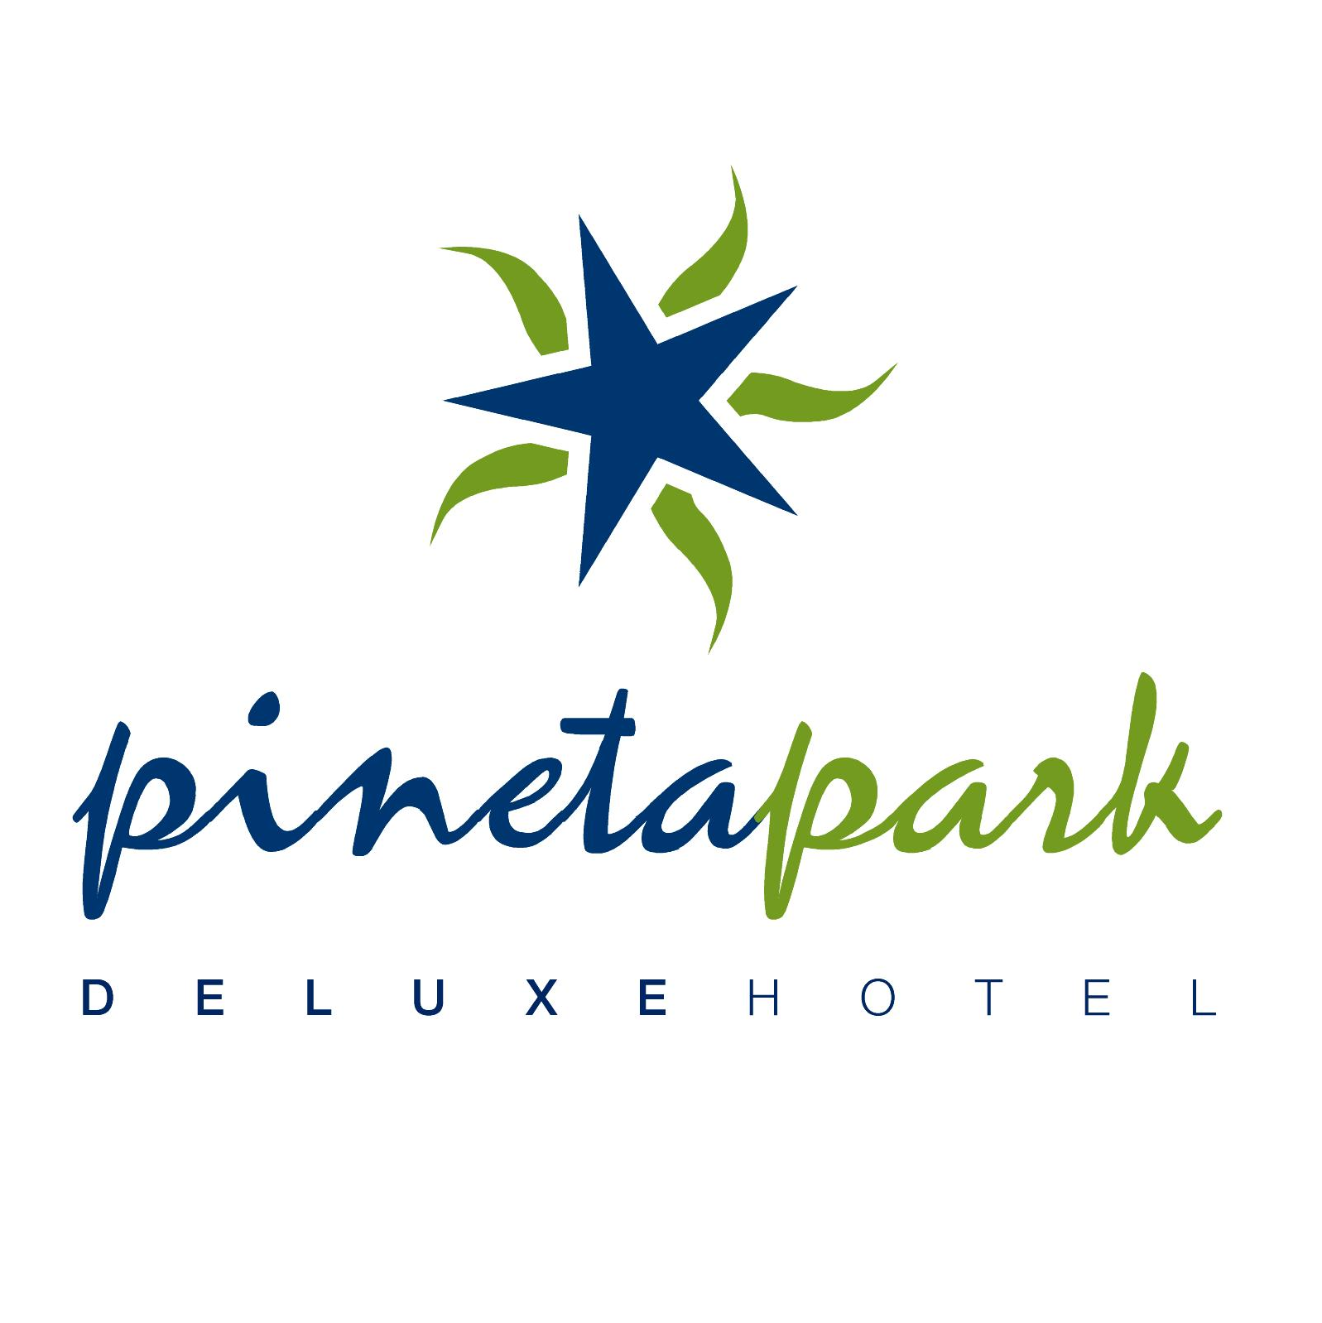

ALL INCLUSIVE (2017)

- THE FOLLOWING SERVICE WILL BE PROVIDED FOR ALL INCLUSIVE GUESTS AS INDICATED
BELOW

MILLENIUM RESTAURANT / SELF SERVICE
- BREAKFAST 07:30 - 10:00 Open buffet self service
- LUNCH 12:00 – 13:30 Open buffet self service
- DINNER 19:00 – 21:00 Open buffet self service

SUNDOWNER POOL BAR SNACK SERVICES
Snack service 14:00 – 16:00 - self service open buffet. A selection will include the likes of the following : Hamburgers, Cheeseburgers, Chicken Burgers, Hot Dogs and Chips or Baked Potatoes All served with Seasonal Salad. Also provided are Bread Rolls and fillings to ‘Make Your Own Sandwich’ . Meals & snacks are served along with local alcoholic drinks, wine, beer & soft drinks within the terms of All Inclusive.

SUNDOWNER POOL BAR :
Offering self service Coffee Break 17:00 – 18:00 including cakes and biscuıts within the terms of All Inclusive.

THE CLUB HOUSE:
Offering self service All Inclusive local alcoholic and Non Alcoholic drinks 10:00 - 23:50 within the terms of All Inclusive.

PINETAPARK TURKISH BATH, SAUNA & FITNESS CENTRE: Turkish bath & sauna available 14:00– 18:00, fitness centre available 10:00– 18:00 within the terms of All Inclusive.

DRINKS SERVICE:
Local Alcoholic drinks within the terms of All Inclusive consist of Vodka, Gin, Rakı, Draught Beer and Draught Wine Soft drinks consist of Cola, Fanta, Concentrated Drinks, Sprite, Soda Water, Tea, Coffee, Milk and Water ( Bottled Water is Chargeable )

OTHER :
Safety Deposit Boxes in the room are free of charge. Our All Inclusive Animation programme includes both an adult’s and children’s programme(4-12 years). Use of the tennis court is free of charge (Usage of lights & equipment hire are chargeable).Billiards and Table Tennis usage is Chargeable.

IMPORTANT NOTE : Any services not listed above are chargeable
WE DO NOT SERVE ALCOHOL TO UNDER 18s

Fatih Sultan Mehmet Cad. Şirinyer Mah 131 Sokak Armutalan/Marmaris – MUĞLA
Tlf..:+90.252.417 24 96-97-98Faks.:+90.252.417 24 99

