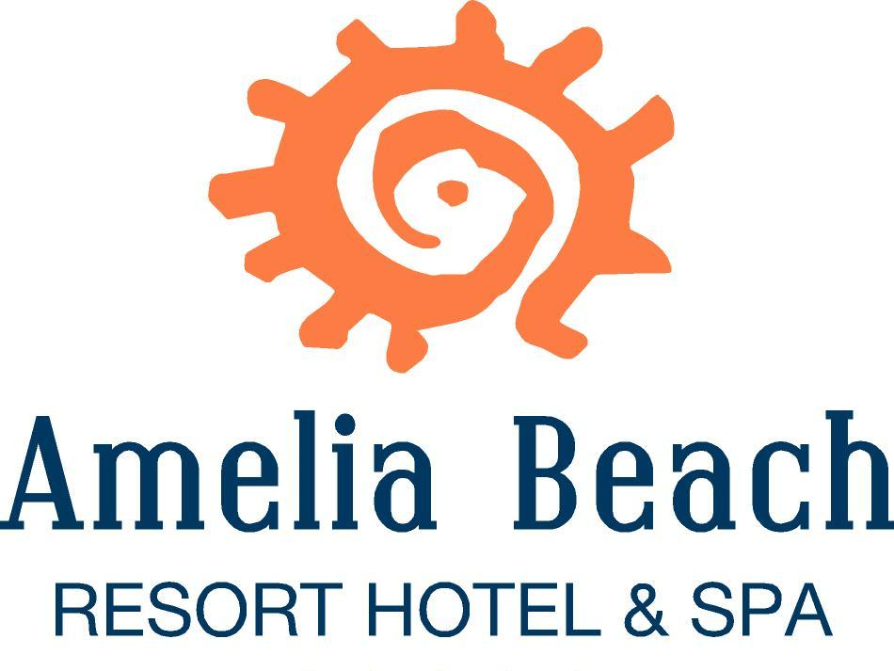

ALL INCLUSIVE FOOD & BEVERAGE CONCEPT - SUMMER 2022

FOOD SERVICES
FOOD SERVICE TIME PLACE MENU

Breakfast 07:00 - 10:00 Main Restaurant Open Buffet staff gives the food in front of the buffet
Late Breakfast 10:00 - 11:00 Main Restaurant Open Buffet staff gives the food in front of the buffet
Lunch 12:30 - 14:30 Main Restaurant Open Buffet staff gives the food in front of the buffet
Snack 12:00 - 16:00 Oleander Bar Snack food table service
Afternoon Tea 16:00 - 17:00 Patisserie Cakes and Biscuits the personal gives
Dinner 19:00 - 21:00 Main Restaurant Open Buffet staff gives the food in front of the buffet
Italian A’la Carte 19:00 - 21:00 Olive Restaurant Upon reservation
Ottoman A’la Carte 19:00 - 21:00 Tulip Restaurant Upon reservation
Chinese A’la Carte 19:00 - 21:00 Bonsai Restaurant Upon reservation
0Fish A’la Carte 19:00 - 21:00 Oleander Restaurant Upon reservation Extra charge 10€
Night Buffet 23:00 - 24:00 Lobby Patisserie Staff gives the food in front of the buffet

BEVERAGE SERVICES
DRINK SERVICE TIME PLACE DRINKS

Table Service 12:30 - 14:30 Main Restaurant Local Alcoholic Drinks - Wines, Beer, Raki, Vodka,
Gin, Soft Drinks, Tea, Coffee, Water, Mineral Water.
Table Service 19:00 - 21:00 Main Restaurant As Above
A'la Carte service 19:00 - 21:00 Olive Restaurant (A’la Carte) As Above
A'la Carte service 19:00 - 21:00 Tulip Restaurant (A’la Carte) As Above
A'la Carte service 19:00 - 21:00 Bonsai Restaurant(A’la Carte) As Above
A'la Carte service 19:00 - 21:00 Oleander Restaurant(A’la Carte)Payment
Table Service 10:00 - 24:00 Pool Bar As Above
Table Service 12:00 - 16:00 Oleander Beach Bar As Above
Table service 24:00 - 02:00 Disco Bar All drinks in the Disco are with extra charge.
FOR YOUR ATTENTION:
• The all Inclusive concept is valid from 10:00h – 24:00h.
• On the day of your departure check-out is till at 12:00h. On first day check-in is from 14:00 o’clock.
• The room safe is charged with €1.50 per day, you can rent it at the reception desk. It is not recommended to take valuables
to the pool or beach areas. The Hotel is not liable in case of theft, loss or damage to belongings. Please report lost or found
items to reception
• Please do not take any valuables to the pool or beach area. The hotel management can not be held responsible in case of
lost.
• In case of damage or loss to your towel card there will be a charge of €5.
In case of damage or loss to your room or safe card there will be a charge of €10.
* Hotel is not responsible for lost items.
• The minibar is replenished daily with soft drinks, water and mineral water.
In Certain times may give ice cream
• Alcohol will not be served to guests under the age of 18.
• All beverages are served by the glass, there is no bottle service.
• The Aquapark working hours are from 10:00h - 12.00h and 15:00h -17.00h (changeable) between the 01/05 - 15/10.
• The Management reserves the right to ammend the place and times of Bar and Restaurant services.
• Children under the age of 18 are not permitted in the Disco and are not allowed to swim in the sea or in the pool without
parental supervision
Wi-fi is available in the Lobby Bar for free and guests can use up to 50 MB per stay. Wi-fi in other areas of the hotel is with charge.
• There is a Doctor service availavle 24 hours (please contact the reception desk ).
• The balcony door must be closed in order for the air conditioning to work.
• The beach towels you receive with your towel card at the Spa & Wellness desk. One change in a day is free of charge. A
second change in a day however is with charge.
• The Lifeguards are not responsible for accidents that may occur in the pools or in the sea when they are not on duty.
• It is forbidden for guests to swim in the pool or sea whilst under the influence of alcohol.
• The meals in the main restaurant and the snack are served to the guests by the staff in front of the buffet
Drinks are served on the table in the main restaurant and in the bars.
Guests are advised to wear masks for health purposes.
During intensive check-in and check-out, the guests must maintain a social distance of at least 1.5 meters.
• Use of the Spa & Wellness Center is at your own risk.
• The Hotel Management can not be held responsible if guests fail to adhere to the above rules.

SERVICES WITH CHARGE:
FRESH FRUIT JUICES, IMPORTED DRINKS, SAFE BOX, FAX, TELEPHONE, GAME MACHINES, WATER SPORTS, MASSAGES, BILLARDS, DOCTOR, LAUNDRY, INTERNET, BOWLING.

