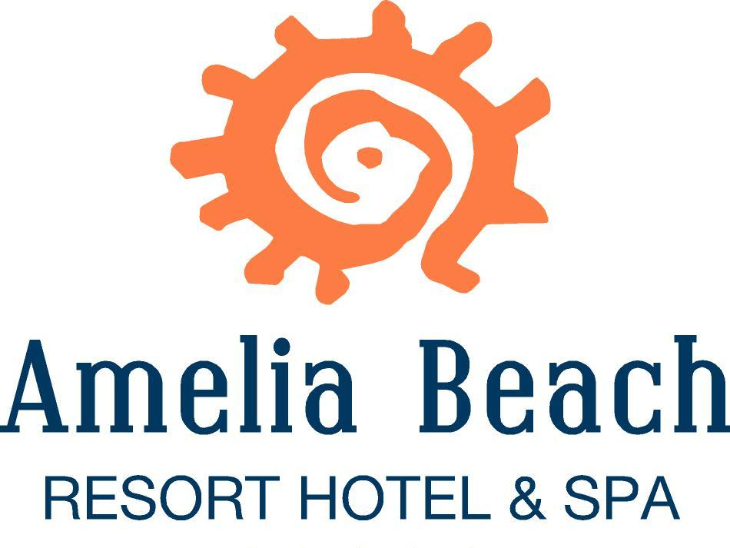

FACT SHEET - SUMMER 2022

HOTEL : AMELIA BEACH RESORT HOTEL & SPA
ADRESS : KIZILOT BELDESİ, ÇENGER KÖYÜ , ÖMER BOĞAZI MEVKİİ
07610 MANAVGAT – ANTALYA
TELEPHONE : +90 242 766 44 00
FAX : +90 242 766 47 89
CATEGORY : 5*
OPENING DATE : May 2008
BOARD TYPE : All Inclusive
WEB : www.ameliabeachresort.com / www.ameliahotels.com
E-MAIL ADDRESS : info@ameliabeachresort.com

LOCATION

The hotel is situated on an area of 50.000 m². Below are the distances from our Hotel to:

The nearest city : Antalya 90 km
The nearest airport : Antalya airport 80 km
The nearest town : Manavgat 15 km
The nearest village : Kızılot and Okurcalar 3 and 4 km

ROOMS

We have 479 rooms: 300 Standard rooms (55 connection rooms, 4 rooms for handicapped) and 179 Family rooms.

- Standard Rooms (300 rooms)
French and Twin bed, Central Air Conditioning (at certain hours), satellite TV with music channel, direct phone, phone in the bathroom, mini-bar, WC, bathroom with a shower, hair dryer, digital safe, balcony. All rooms are 36m² with parquet flooring.

- Family Rooms - Type A (122 rooms)
Bigger than the standard rooms, the Family Rooms – Type A have one French bed and a bunk bed. Room facilities are the same as offered in the Standard Rooms. Rooms are 36 - 39m².

- Family Rooms - Type B (24 rooms)
2 separate rooms with a connection door and one bathroom. In one room is a French bed in the other room one twin bed and sofa. Room facilities are the same as offered in the Standard Rooms. Rooms are 43m².

- Family Rooms - Type C (33 rooms)
2 separate rooms with a connection door and 2 separate bathrooms. In one room is a French bed, in the other room 2 twin beds. Room facilities are the same as offered in the Standard Rooms. Rooms are 72m².

- Annex Rooms (31 rooms)
2 twin beds, Central Air Conditioning (at certain hours), satellite TV, with music channel, direct phone, mini-bar, WC, bathroom with a shower, hair dryer, digital safe, balcony. Rooms are 19m².

WI-FI

Wi-fi is available in the Lobby Area for free and guests can use up to 50 MB per stay. Wi-fi in other areas of the Hotel is with charge.

ALL INCLUSIVE

All local alcohol and non-alcohol drinks are included. The All Inclusive concept is from 10:00 till 24:00. In the Disco all alcoholic and non-alcoholic drinks are with charge

FOOD & BEVERAGE OUTLETS

- Main Restaurant
Breakfast, Late breakfast, Lunch, Dinner (Children’s and Diet Menu available) and Night Soups are served in the Main restaurants for the Guests.

Indoor Capacity : 700 pax Outdoor Capacity: 400 pax

- A’la Carte Restaurants
In our A’la Carte Restaurants, our well trained staff serves delicious food from Turkish, Italian, Fish and Chinese Cuisine. Guests can visit one restaurant per 4 nights. Reservation is required.

Turkish Restaurant Capacity: 50 pax (From May 01 to October 15)
Chinese Restaurant Capacity: 50 pax (From May 01 to October 15)
Italian Restaurant Capacity: 50 pax (From June 01 to September 30)
Fish Restaurant Capacity: 50 pax (From June 1 to September 30 Extra charge 10€)

- Patisserie
Different varieties of cakes and biscuits are served daily with teas and coffees.

- Bars
Guests can enjoy their favorite drinks in the below bars:

Lobby Bar, Snack Bar, Pool Bar, Beach Bar, Disco Bar (with charge), Vitamin Bar (with charge).

- Room Service
24 hour room service is available with charge.

MEETING HALLS

We have 2 meeting rooms. The Capacity of the meeting rooms are given below:

Name | Name | M2 | High | Lenght | Width | Theatre | Classroom | U-Shape
Daphne | 754 | 340 cm | 20,75 | 36,35 | 800 pax | 400 pax | 200 pax | 400 pax
Camelia | 111 | 350 cm | 9,50 | 11,70 | 50 pax | 25 pax | 50 pax | 25 pax

Equipment:
Overhead Projector & Canvas (4,5m)
Projector / Barcovision
Full sound system
Wireless or cable Microphone.

SWIMMING POOLS

At the Pools, sun beds, sun mattresses, parasols and beachs towel are free of charge. The Towel desk is open from 09:00 till 12:00 and from 14:00 till 17:00. A second towel change in a day is with charge.

Indoor Pool Size: 150m² Depth: 1m 40cm Closed from 01.06 – 15.10
Outdoor Pool Size: 2600m² Depth: 1m 40cm
Water Slide Pool Size: 220m² Depth: 1m 40cm Open from 01.05 – 15.10
Relax Pool Size: 170m² Depth: 1m 40cm
Children’s Pool Size: 50m² Depth: 35cm

BEACH

We have a Blue Flag beach. Blue Flag is the international certificate which shows the cleanliness of the sea. The beach has fine sand with pebbles. The way to the beach is through an underground tunnel. On the beach, sun mattresses, parasols and beach towel are free of charge.

ENTERTAINMENT AND SPORTING ACTIVITIES

- Animation
The Animation Program is in Turkish, German, English and Russian languages. The Amphitheater has a capacity of 1000 pax. Every night there are soft Animation Shows, with Themed nights (Turkish night etc.) once every 2 weeks. Daily activities include Children’s Animation, aerobics, gymnastics, darts, table tennis, step, boccia, air gun shooting and beach volleyball.

- Sports
We have 2 Tennis Courts and 1 basketball playing ground. Reservation is required. Use of the Tennis courts and basketball playing ground is free but renting Tennis equipment or the use of floodlighting is with charge.

- Playing Room
Bowling, billiards, internet in the game room, play station and electronic darts are with charge.

- Disco
The Disco has a capacity of 170 pax. Entrance to the Disco is free but all drinks (alcoholic or non-alcoholic) are with charge. Teenagers under the age of 18 are not permitted in the Disco. The Disco is only open on certain days.

WELLNESS & SPA CENTER

With our Professional Staff, the latest technology and the mystical atmosphere, in the “Sanus Per Aquam” (from the Latin meaning ‘Health Through Water’) Spa Centre, you can enjoy following services:

Turkish Hamam : Free of Charge
Sauna : Free of Charge
Fitness Room : Free of Charge
Face treatments : With Charge
Massage and Peeling : With Charge

Use of the spa at your own risk.

OTHER SERVICES (WITH CHARGE)

Babysitting (reservation necessary), Doctor (certain hours), Rent a Car, Hairdresser, Laundry and Dry Cleaning, Photo shop, Mini-Market, Water Sports (on the beach) and Freshly squeezed fruit juices.

ADDITIONAL INFORMATION

Because of hygienic reasons, pets are not allowed in our hotel.
Wearing an all inclusive / hotel bracelet is mandatory.
Alcoholic beverages are only served to people over the age of 18.
The service times and locations / places can be changed by the hotel management depending on the season / weather.
Children under the age of 15 are not allowed to use the swimming pool without parental assistance.
Children under the age of 16 are not allowed to use the sea without parental assistance
Guests with high alcohol consumption are prohibited from using the swimming pool or the sea.
The meals in the main restaurant and the snack are served to the guests by the staff in front of the buffet.
The temperature of the guests entering the hotel is measured by the staff when entering the hotel.
Guests should report symptoms (high fever, dry cough, shortness of breath, loss of taste and smell) immediately to the reception or the guestrelations.
Guests must sign a form detailing the country they arrived in, the countries they have traveled to in the past few days, and addresses and phone numbers that can be provided to contact them in our country, and whether the guest shows symptoms of Covid-19 During his stay, he undertakes to implement the Covid-19 action plan set by the administration.
During intensive check-in and check-out, the guests must maintain a social distance of at least 2 meters.
If the guest's suitcase is protected by a stretch or protective case, the protective stretch or protective case at the hotel entrance should be removed.
Drinks are served on the table in the main restaurant and in the bars.
The position of the sun loungers and tables in the restaurant by the pool and on the beach is determined by the hotel management according to the social distance. The guests will not move if not necessary.
Guests are advised to wear masks for health purposes.
Guests are advised to turn their backs on each other when moving up.
The hotel administration and staff may apply temporary restrictions on the use of the common area and restaurant when they deem it necessary, if there is a threat of violation of the rules of social distance.
Due to the fact that these activities will be carried out in order to prevent risks to the health of guests and hotel staff, guests acknowledge that the restrictions will not be subject to any complaints or claims on their part.
In the event of non-compliance with the above, the hotel assumes no liability.

