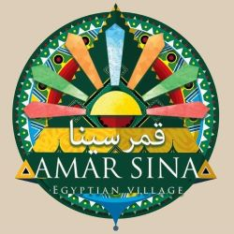
All-Inclusive Formula
(10:00 AM – 22:00 PM)

Breakfast Main Restaurant 07.00 – 09.00
Light lunch Main Restaurant 13.00 – 15.00
Dinner Main Restaurant 19.00 – 21.00
Beverage Pool Bar / Lobby Bar 10.00 – 22.00
Beverage on Pool & Lobby Bar Includes:
Water, Soft drinks, Tea, American coffee, Alcoholic local Spirits, Non-alcoholic & alcoholic Cocktails. & all will be served by glasses.
Beverage Excludes:
Wine, Beer, Fresh Juices, Espresso, Cappuccino and Turkish coffee
General Remarks:
- It’s not allowed to take any food or beverage outside the restaurant; if you have any special requirement, please contacts our restaurant manager to assist you.
- Room service is for extra charges and not included the all-inclusive formula.
- All drinks will be by self-service during the opening hours of the above-mentioned bars and restaurant
- Free WI-FI only in reception area

- N.B:

- Drinks are served in by glasses in all areas.
- Any consumption based on full bottles will be paid cash
- All Inclusive package is valid till 12:00 Hr noon time at the day of departure.

