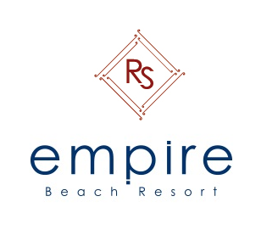
Dear Guest,
Thank you for choosing Empire Beach Resort as your holiday destination.
Royal Star Beach Resort offers you a charming atmosphere where you can enjoy and relax at one
of our pools or the Red Sea beach enjoying the sunny and warm weather.
- Reception: Open 24H. Ext: 0
- Hotel doctor: Available 24 Hours, Please contact the Reception. Ext.:0

Opening and closing times of bars and restaurants:

Olives Restaurant Breakfast buffet from 07:00 am till 10:00 am
Olives Restaurant Lunch buffet from 12:30 pm till 14:30 pm
Olives Restaurant Dinner buffet from 18:30 pm till 21:00 pm

Sunny Terrace morning tea from 10:00 am till 11:00 am
Coffee and Snacks from 16:00 pm till 17:00pm
Drinks from 10:00 am till 17:00 pm
Coral bar Drinks from 17:00 pm till 24:00 pm
Oasis bar Drinks from 18:00 pm till 24:00 pm
- After 11 pm the beverages are not all inclusive anymore.
- The all inclusive system stops the day of departure at 12.00 NOON
- We offer different kind of cocktails with alcohol and without alcohol

Not all inclusive (charged extras):
- Ice cream , Milk shakes based on ice cream, Espresso, Wine & Fresh fruit juices
- Mini bar consumption
- Imported alcoholic drinks
- Laundry
- Doctor (medical services and needs)
- Health Club & Beauty Center
- Snorkeling & diving courses, excursions
.
Safe Box: the management takes no responsibility for valuables left in the rooms, safe deposit boxes are available free of charge
Checkout Time: 12:00 PM noon
For more information please contact our Guest Relation or Reception
Hotel Map

