
Havana Hotel

FACT SHEET 2023
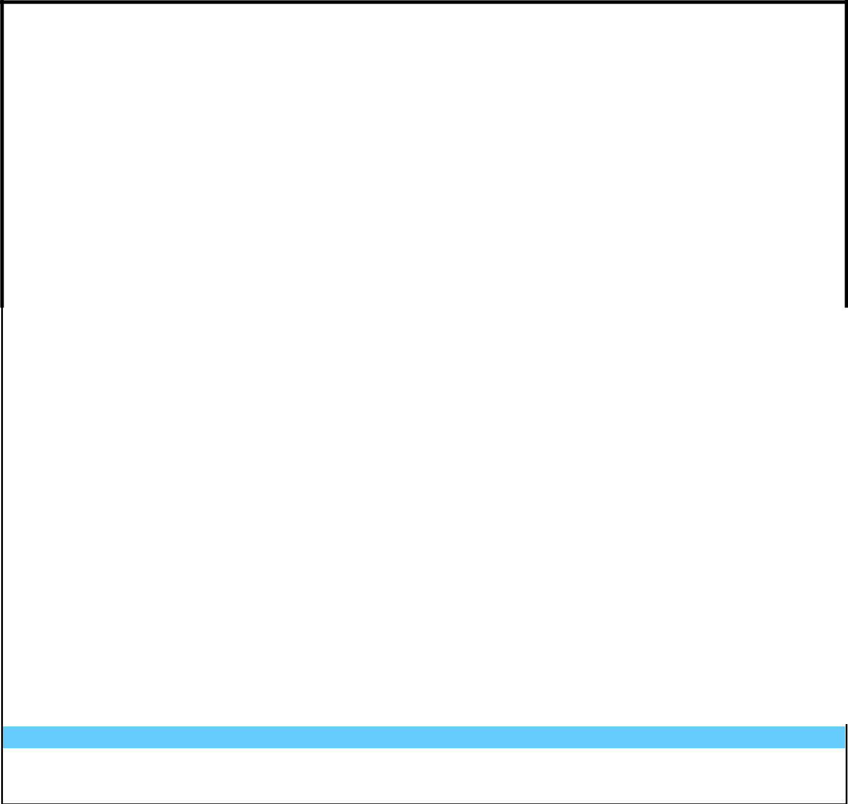

 |  |  | HOTEL: HAVANA |  |  |  |  |  |  |  |  |  |  |  |  |  |  |  |  |  |  |  |  |  |  |  |  |  |  | DISTANCE: |  |  |  |  |  |  |  |  | Hotel information:
 |  |  | ADRESS: GOLDEN SANDS resort |  |  |  |  |  |  |  |  |  |  |  |  |  |  |  | To the airport |  |  |  |  |  |  |  |  |  |  |  | 20 кm |  |  |  |  |  |  |  | Category: |  |  | 4*
 |  |  | ADRESS: BULGARIA, VARNA 9007, GOLDEN To the center |  |  |  |  |  |  |  |  |  |  |  |  |  |  |  |  |  |  |  |  |  |  |  |  |  |  |  | 400 m |  |  |  |  |  |  |  | License: |  |  | РК-19-12816
 |  |  |  |  |  |  |  |  |  |  |  |  |  |  |  |  |  |  | To Varna |  |  |  |  |  |  |  |  |  |  |  | 15 кm |  |  |  |  |  |  |  | Buildings: |  |  | 1
 |  |  |  |  |  |  |  |  |  |  |  |  |  |  |  |  |  |  | To the beach |  |  |  |  |  |  |  |  |  |  |  | 400 m |  |  |  |  |  |  |  | Boarding:
 |  |  |  |  |  |  |  |  |  |  |  |  |  |  |  |  |  |  |  |  |  |  |  |  |  |  |  |  |  |  |  |  |  |  |  |  |  |  |  |  |  | HB, ALL
 |  |  |  |  |  |  |  |  |  |  |  |  |  |  |  |  |  |  |  |  |  |  |  |  |  |  |  |  |  | Снимки: HAVANA |  |  |  |  |  |  |  |  | Area m2:
 |  |  |  |  |  |  |  |  |  |  |  |  |  |  |  |  |  |  |  |  |  |  |  |  |  |  |  |  |  |  |  |  |  |  |  |  |  |  |  |  |  | 14000
 |  |  |  |  |  |  |  |  |  |  |  |  |  |  |  |  |  |  |  |  |  |  |  |  |  |  |  |  |  |  |  |  |  |  |  |  |  |  | Build Year: |  |  | 14000
 |  |  |  |  |  |  |  |  |  |  |  |  |  |  |  |  |  |  |  |  |  |  |  |  |  |  |  |  |  |  |  |  |  |  |  |  |  |  |  |  |  | 2001
 |  |  |  |  |  |  |  |  |  |  |  |  |  |  |  |  |  |  |  |  |  |  |  |  |  |  |  |  |  |  |  |  |  |  |  |  |  |  | Last renovated: |  |  | 2020
 |  |  |  |  |  |  |  |  |  |  |  |  |  |  |  |  |  |  |  |  |  |  |  |  |  |  |  |  |  |  |  |  |  |  |  |  |  |  | Pets: |  |  | NO
 |  |  |  |  |  |  |  |  |  |  |  |  |  |  |  |  |  |  |  |  |  |  |  |  |  |  |  |  |  |  |  |  |  |  |  |  |  |  | Credit cards accepted
 |  |  |  |  |  |  |  |  |  |  |  |  |  |  |  |  |  |  |  |  |  |  |  |  |  |  |  |  |  |  |  |  |  |  |  |  |  |  | Visa |  |  | •
 |  |  |  |  |  |  |  |  |  |  |  |  |  |  |  |  |  |  |  |  |  |  |  |  |  |  |  |  |  |  |  |  |  |  |  |  |  |  | Master |  |  | •
 |  |  |  |  |  |  |  |  |  |  |  |  |  |  |  |  |  |  |  |  |  |  |  |  |  |  |  |  |  |  |  |  |  |  |  |  |  |  | Currency exchange |  |  | •
 |  |  |  |  |  |  |  |  |  |  |  |  |  |  |  |  |  |  |  |  |  |  |  |  |  |  |  |  |  |  |  |  |  |  |  |  |  |  |  | Spoken languages: Bulgarian,
 |  |  |  |  |  |  |  |  |  |  |  |  |  |  |  |  |  |  |  |  |  |  |  |  |  |  |  |  |  |  |  |  |  |  |  |  |  |  |  |  | English,Russian
 |  |  | * Accommodation time-14h. All Inclusive bracelets are received after check-in and not earlier than 14:00; |  |  |  |  |  |  |  |  |  |  |  |  |  |  |  |  |  |  |  |  |  |  |  |  |  |  |  |  |  |  |  |  |  |  |  |  | Smoking in the lobby of the hotel,
 |  |  |  |  |  |  |  |  |  |  |  |  |  |  |  | * Check-out - 11.30h. |  |  |  |  |  |  |  |  |  |  |  |  |  |  |  |  |  |  |  |  |  |  |  | restaurant, bars and rooms is not
 |  |  |  |  |  |  |  |  |  |  |  | *Early check-in and late check-out are extra costs. |  |  |  |  |  |  |  |  |  |  |  |  |  |  |  |  |  |  |  |  |  |  |  |  |  |  |  | permitted under Bulgarian law;
 |  |  | Rooms Information: |  |  |  |  |  |  |  |  |  |  |  |  |  |  |  |  |  |  |  |  |  |  |  |  |  | Restaurant and Bars:
 |  |  |  |  |  |  |  |  |  |  |  |  |  |  |  |  |  | Main Restaurant - 120 |  |  |  |  |  |  |  |  |  |  |  |  |  | Out site: 30 |  |  |  |  |  |  |  | In site: 120
 |  |  | Number of floors: |  |  |  |  |  |  |  | 15 |  |  |  |  |  |  | Bars: 3 |  |  |  |  |  |  |  |  |  |  | 1. Lobby bar |  |  | 2. Pool bar |  |  |  |  |  |  |  | 3. Restaurant bar
 |  |  | Number of rooms: |  |  |  |  |  |  |  | 128 |  |  |  |  |  |  | Working hours can be changed depending on hotel policy and weather conditions.
 |  |  | Rooms area m2 (incl. Balcony) |  |  |  |  |  |  |  |  | 18-25 м² |  |  |  |  |  | All inclusive |  |  |  |  |  | from/to Hour |  |  |  |  | Meals 08:00 – 21:00 |  |  |  | Drinks 10:00 – 22:00
 |  |  | Maximum occupancy: |  |  |  |  |  |  |  | 2+2 |  |  |  |  |  |  | Meals: Buffet in Main restaurant
 |  |  | Sea view (number) |  |  |  |  |  |  |  | 52 |  |  |  |  |  |  | Breakfast: |  |  |  |  |  | 08:00–10.30 / Incl – Water, Just and hot drinks (for ALL incl and HB)
 |  |  | Land view (number) |  |  |  |  |  |  |  | 76 |  |  |  |  |  |  | Lunch: |  |  |  |  |  | 12:30–14:30 / Incl – Water, Just, Local alcoholic and non-alcoholic drinks, hot drinks, draft beer and wine (for ALL incl)
 |  |  | Baby cot: |  |  |  |  |  |  |  |  | Yes/ extra cost |  |  |  |  |  | Dinner: |  |  |  |  |  | 18:30–21:00 / Incl – Water, Just and hot drinks (for ALL incl and HB), Local alcoholic and non-alcoholic drinks, hot
 |  |  |  |  |  |  |  |  |  |  |  |  |  |  |  |  |  |  |  |  |  |  |  | drinks, draft beer and wine (for ALL incl)
 |  |  | Extra bed: |  |  |  |  |  |  |  |  | Yes
 |  |  | Bathtub: |  |  |  |  |  |  |  |  | Yes |  |  |  |  |  | Lobby bar: |  |  |  |  |  | 10:00-22:00 / Local alcoholic and non-alcoholic drinks, soft drinks and just, hot drinks, draft beer and wine;
 |  |  | Shower: |  |  |  |  |  |  |  |  | Yes |  |  |  |  |  | Pool bar: |  |  |  |  |  | 10:00-16:30 / Local alcoholic and non-alcoholic drinks, soft drinks and just, hot drinks, draft beer and wine;
 |  |  | Hairdryer: |  |  |  |  |  |  |  |  | Yes |  |  |  |  |  | Intermediate |  |  |  |  |  | 10:30-12:00 / Buffet – sandwiches, sweets and fruits – between main meals;
 |  |  | Air conditioner: |  |  |  |  |  |  |  |  | Central |  |  |  |  |  | snacks: |  |  |  |  |  | 15:00-17:00 / Buffet – sandwiches, sweets and fruits – between main meals;
 |  |  | TV |  |  |  |  |  |  |  |  | Sat
 |  |  | Phone: |  |  |  |  |  |  |  |  | Yes/ extra cost |  |  |  |  |  |  |  |  |  |  |  |  |  |  |  |  | Pool services:
 |  |  | Mini bar: |  |  |  |  |  |  |  |  | Yes/ extra cost |  |  |  |  |  | Outdoor swimming pool: Yes Number: 2 Children swimming pool: Yes Heat: No Size: 500м³
 |  |  | Refrigerator |  |  |  |  |  |  |  |  | Yes |  |  |  |  |  | Tower: free
 |  |  | Safe |  |  |  |  |  |  |  |  | In the rooms |  |  |  |  |  | Sun lounges and parasols at the swimming pool: free
 |  |  | Flooring: |  |  |  |  |  |  |  |  | carpet |  |  |  |  |  | ** For abandoned unattended towels around the pool the hotel is not responsible; reservation of sun loungers Not accepted
 |  |  | Balcony: |  |  |  |  |  |  |  |  | Yes/ not in all |  |  |  |  |  | **Lifeguard at the swimming pool - working hours: 09.00-17.00.
 |  |  | Internet: |  |  |  |  |  |  |  |  | Wi-Fi |  |  |  |  |  |  |  |  |  |  |  |  |  |  |  |  | Room cleaning: every day
 |  |  | Room Service: |  |  |  |  |  |  |  |  | Yes/extra cost |  |  |  |  |  | bed-clothes change: |  |  |  |  |  |  |  |  |  |  |  |  |  |  |  |  |  |  |  |  |  |  | Every 3 days
 |  |  |  |  |  |  |  |  |  |  |  |  |  |  |  |  |  | towels change: |  |  |  |  |  |  |  |  |  |  |  |  |  |  |  |  |  |  |  |  |  |  | Every day
ROOM TYPE: (description, number, m2...)

TWN/DBL-FPV – 61 rooms – 22 m² – DOUBLE ROOM FRONT PARK VIEW with one double or two single beds, extra bed, shower or bath, balcony; accommodation - 2+2/3+1

TWN/DBL-SV - 48 rooms – 20 m² – DOUBLE ROOM SEA VIEW with one double or two single beds, extra bed, shower or bath, balcony; accommodation - 2+1/1+2

TWN/SNG/ECONOMIC – 15 room – 18 m² – DOUBLE ROOM PARK VIEW for double or single use with one double or two single beds, shower or bath, No Balcony, accommodation - 2+0/1+0

Services: | Paid | Free |  | Services for children: | Yes | No
Sauna | * |  |  | Children buffet: |  | *
Turkish bath | * |  |  | Baby meal: |  | *
Steam bath | * |  |  | Play ground: | *
Fitness |  | * |  | Animation for children: |  | *
Massages | * |  |  | Child section/outdoor swimming pool: | *
Jacuzzi |  |  |  | High chairs in the restaurant | *
SPA: |  |  |  | Mini club |  | *
Hairdressing services:
Laundry: | *
Face therapy: | * |  |  | Other | Yes | No
Body therapy: | * |  |  | Rent a car | *
Wi-Fi |  | * |  | Shop: | *
Parking | * |  |  | Medical help: | *

