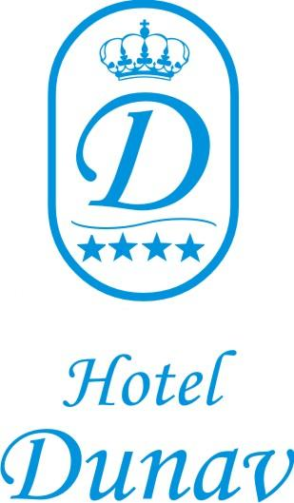
Summer 2023
The AI program runs from 10:00 to 22:00
FOOD:
Breakfast: from 7:30 to 10:00
- breakfast buffet in the Main Restaurant;
Lunch: from 12:00 to 14:00
- lunch buffet in the Main Restaurant;
- lunch served in the Pizza Restaurant;
Dinner: from 18:00 to 20:00
- dinner buffet in the Main Restaurant;
- dinner served in the Fish Restaurant;
Snacks:
- from 10:00 to 17:00 – pizza and spaghetti;
- from 12:00 to 14:00 – burgers;
Buffets around the swimming pools
- tee – from 10:00 to 20:00
- coffee - from 10:00 to 20:00;
- Lights desserts from 10:00 to 20:00
- Ice cream: from 10:00 to 17:00 – 6 types of ice cream.
DRINKS:
Drinks served 24 hours a day.
- Lobby Bar: AI - from 10:00 to 22:00;
- Pool Bar: AI – from 10:00 to 22:00;
- Main Restaurant – during the meals;
- Pizza Restaurant – during the meals;
- Fish Restaurant – during the meals;
AI drinks are as listed below:
- mineral water;
- soft drinks;
- local beer;
- local spirits;
VARIOUS:
AI bracelet.
GYM – free of charge for all inclusive guests.
Wi-Fi – free of charge – in the lobby area and in the rooms.
ENTERTAINMENT & RELAXATION:
Animation program– free of charge – only three times per week:
- children animation;
- folklore program;
- flamenco program.
- According pandemic situation , hotel will inform about changes of the program if it will have it

