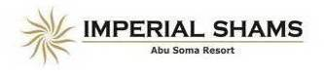

**Imperial Shams Abu Soma resort**

**All Inclusive Formula**

*Dear Guests*

*On behalf of the hotel’s management we would like to sincerely welcome you to Imperial Shams Abu Soma resort,* we are honored that you have chosen our resort for your stay and look forward providing you with a memorable experience *and pleasant stay.*

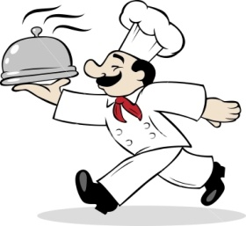**Restaurants:-**

**Main restaurant (La Bonbonera )**

* Breakfast from 07:00 till10:00
* Lunch from 13:00 till 15:00
* Dinner from 19:00 till 22:00

**Ala carte restaurants:**

**Italian Restaurant "Porto Fino” (Once per stay - Minimum stay one week)**

* Serve dinner from 19:00 to 22:00
* Reservation one day in advance from 07:00am till 10:00am in main restaurant.
* 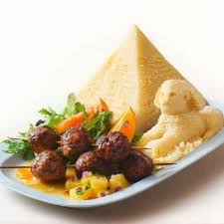

**Oriental Restaurant “ El khan" (Once per stay – Minimum stay one week )**

* Serve dinner from 19:00 to 22:00
* Reservation one day in advance from 07:00am till 10:00am in main restaurant.

**Cafes & bars:-**

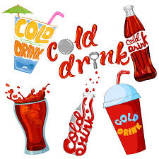

**Lobby bar ”** **La Siesta”**

* Wide selection of soft drinks available 24 hours.
* Selected local alchohlic beverges from 10:00 am till 06:00 am



**Pool & beach bar “Bonjour “**

* Serve soft and selected local alchohlic drinks from 10:00 till 17:00.
* Hot snack and sandwiches from 13:00 till 16:00.

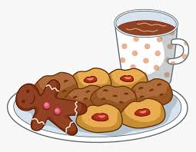**Coffee shop ” Il Passo”**

* Late light breakfast from 10:30 till 12:00.
* Cold Snacks and coffee break from 15:00 till 17:00.
* Ice cream is available from 19:00 till 22:00.

**English bar "XUXU's"**

* Opened in evening time for specail occasins in relaxing atomsphere

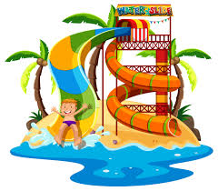**Activities and services free of charges:**

* Daily animation activities with music around pools & beach area.
* Evening entertainment & Groove Disco.
* Aqua park (Neighbor hotel / Shams Safaga).
* Squash & Tennis court (Neighbor hotel / Shams Safaga).
* 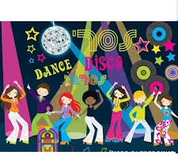Beach volleyball/ Boccia /Darts.
* Billiard room.
* Table Tennis.
* Fitness room.
* Kids club & Kids play ground.
* Free Wi-Fi browsing access in the lobby area only.

**Activities and services against charges ( Not included ) :-**

* Wellness & Spa center
* Wi-Fi ( Internet service)
* Medical service
* Selected cocktails & Fresh juices & Turkish coffee
* Diving & Glass boat & Fishing trips
* Wind & kite surfing
* Horse & Camel riding
* Tennis-court (With lights)

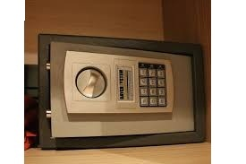

**To use the Safe**

* Open the safe door
* Press the inner red button at the back side of the safe door
* Enter numbers which will be your secret code, then press the button (A)
* Repeat the same code and then press the button (A)
* Turn the knob of the safe door to the left direction, you will find your safe was closed.

**To open the Safe:**

* Enter your code number, and then press the button (A)

Turn the knob of the safe door to the right direction, you will find your safe was opened

**Dear our Guest during your stay,kind ly be aware of the following:**

* Check in time at 14:00, Check out time 12.00 o´clock .
* After 12:00 O’clock of the depature day extra charges are applicable, Kindly contact reception desk earlier for late check out fees.
* Safe boxes are available in the room free of charge; the hotel is not liable for any lost or unsecured items regarding this matter.
* It is not allowed to reserve the sun beds at the beach or swimming pool at night or in early morning and the hotel management has the right to take the proper action.
* Swimsuit isn’t allowed in lobby area or restaurants
* Kindly be aware that according to egyption law, topless (for women) is forbidden, both within the hotel or at the beache & pool areas.
* To enjoy the quiet of you and the neighbors, please use the key to open and close the room door.
* Children are reasonability and under supervision of their parents during the stay.
* To call another room kindly press 2+ rooms No. for ground floor rooms press 20+room No.
* **To call reception press (0) or (3).**

If you have any further questions or requests during your stay our staff will be pleased to assist you just call the front desk and we will be at your service.

Wishing you a comfortable and pleasant stay.

Hotel mangement