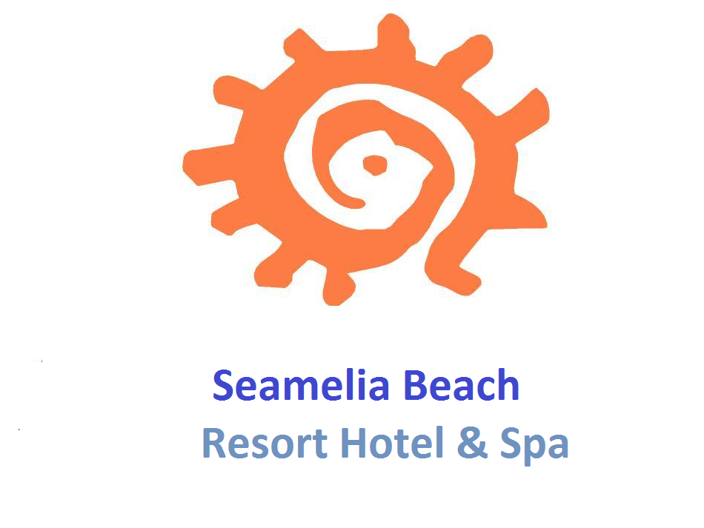

FACT SHEET - SUMMER 2022

HOTEL : SEAMELIA BEACH RESORT HOTEL & SPA
ADRESS : EVREN MAHALLESİ 24 NO LU SOKAK NO:9
07623 EVRENSEKİ - MANAVGAT - ANTALYA
TELEPHONE : +90 242 777 00 02-07 pbx
FAX : +90 242 777 00 01
CATEGORY : 5*
OPENING DATE : JUNE 2011
BOARD TYPE : All Inclusive
WEB : www.ameliabeachresort.com/www.ameliahotels.com
E-MAIL ADDRESS : info@ameliabeachresort.com

LOCATION

The hotel is situated on an area of 12.000 m². Below are the distances from our Hotel to:

The nearest city : Antalya 55 km
The nearest airport : Antalya airport 45 km
The nearest town : Manavgat 10 km
The nearest village : Side Centrum 07 km

ROOMS

We have 300 rooms: 245 Standard rooms, 45 Bunk bed rooms and 10 Family rooms.

- Standard Rooms ( 245 rooms)
Two Twin beds and one sofa, Central Air Conditioning (at certain hours) , satellite TV with music channel, direct phone, phone in the bathroom, mini-bar, WC, shower, hair dryer, digital safe (extra) and balcony. All rooms are 35m² with parquet flooring.

- Bunk bed rooms ( 45 rooms )
Bigger than the standard rooms, the Bunk Bed Rooms have One French bed and a bunk bed. Room facilities are the same as offered in the Standard Rooms. Rooms are 35m².

- Family Rooms ( 10 rooms )
2 separate rooms with connection door and 2 separate bathrooms. In one room is a French bed, in the other room 2 twin beds. Room facilities are the same as offered in the Standard Rooms. Rooms are 50m².

WI-FI

Wi-fi is available in the Lobby Bar for free and guests can use up to 50 MB per stay. Wi-fi in other areas of the Hotel is with charge.

ALL INCLUSIVE

All local alcohol and non-alcohol drinks are included. The All Inclusive concept is from 10:00 till 24:00. In the Disco all alcoholic and non-alcoholic drinks are with charge.

FOOD & BEVERAGE OUTLETS

- Main Restaurant
Breakfast, Late breakfast, Lunch, Diner (Children’s and Diet Menu available), Night Soups are served in the Main restaurants for the guests.

Capacity: 700 pax

- A’la Carte Restaurants
In our A’la Carte Restaurants, our well trained staff serves delicious food from Fish, Turkish, Italian and Chinese Cuisine. Guests can visit one restaurant per 4 nights. Reservation is required.

Turkish Restaurant Capacity: 60 pax (15.04-30.09)
Italian Restaurant Capacity: 40 pax (01.06-30.09)
Chinese Restaurant Capacity: 40 pax (15.04-30.09)
Fish Restaurant Capacity: 40 pax (01.06-30.09 extra charge 10€ )

- Patisserie
Different varieties of cakes and biscuits are served daily with teas and coffees.

- Bars
Guests can enjoy their favorite drinks in the below bars:

Lobby Bar, Snack Bar, Pool Bar, Beach Bar, Terrace Bar, Disco Bar (with charge).

- Room Service
24 hour room service is available with charge.

MEETING HALLS

We have 2 meeting rooms. The Capacity of the meeting rooms are given below:

Name | M2 | High | Lenght | Width | Theatre | Classroom | U-Shape | Banquet
Meeting Room | 535 | 280 cm | 23 m | 23 m | 360 pax | 220 pax | 120 pax | 220 pax
Salon 2 | 85 | 280 cm | 10 m | 8 m | 140 pax | 60 pax | 40 pax | 60 pax

Equipment;
Full sound system

SWIMMING POOLS

At the Pools, sun beds, sun mattresses, parasols and beachs towel are free of charge. The Towel desk is open from 09:00 till 12:00 and from 14:00 till 17:00. A second towel change in a day is with charge.

Indoor Pool Size: 200 m2 Depth : 1m 40 cm Open from 15.10- 30.05
Open Swimming Pool Size: 980 m2 Depth : 1m 40 cm
Water Slide Pool Size: m2 Depth : 1m 40 cm Open from 01.05 – 15.10
Children’s Pool (outdoor) Size: 25 m2 Depth : 35 cm
Children’s Pool (Indoor) Size: 18 m2 Depth : 35 cm

BEACH

Out Hotel is directly on the beach with clean water and fine sand. On the beach, sun mattresses, parasols and beach towel are free of charge.

ENTERTAINMENT AND SPORTING ACTIVITIES

- Animation
The Animation Program is in Turkish, German, English and Russian languages. The Amphitheater has a capacity of 600 pax. Every night there are soft Animation Shows, with Themed nights (Turkish night etc.) once every 2 weeks. Daily activities include Children’s Animation, aerobics, gymnastics, darts, table tennis, step, boccia and beach volleyball.

- Disco
The Disco is 500 m² and has a capacity of 350 pax. Entrance to the Disco is free but all drinks (alcoholic or non-alcoholic) are with charge. Teenagers under the age of 18 are not permitted in the Disco. The Disco is only open on certain days.

WELLNESS & SPA CENTER

With our Professional Staff, the latest technology and the mystical atmosphere, in the “Sanus Per Aquam” (from the Latin meaning ‘Health Through Water’) Spa Centre, you can enjoy following services:

Turkish Hamam : Free of Charge
Sauna : Free of Charge
Fitness : Free of Charge
Face treatments : With Charge
Massage and Peeling : With Charge

OTHER SERVICES (WITH CHARGE)

Babysitting (reservation necessary), Doctor (certain hours), Rent a Car, Hairdresser, Laundry and Dry Cleaning, Photo shop, Mini-Market, Water Sports (on the beach) and Freshly squeezed fruit juices.

OTHERS
Because of hygienic reasons, pets are not allowed in our hotel.
Wearing an all inclusive / hotel bracelet is mandatory.
Alcoholic beverages are only served to people over the age of 18.
The service times and locations / places can be changed by the hotel management depending on the season / weather.
Children under the age of 15 are not allowed to use the swimming pool without parental assistance.
Children under the age of 16 are not allowed to use the sea without parental assistance
Guests with high alcohol consumption are prohibited from using the swimming pool or the sea.
The meals in the main restaurant and the snack are served to the guests by the staff in front of the buffet.
The temperature of the guests entering the hotel is measured by the staff when entering the hotel.
Guests should report symptoms (high fever, dry cough, shortness of breath, loss of taste and smell) immediately to the reception or the guestrelations.
Guests must sign a form detailing the country they arrived in, the countries they have traveled to in the past few days, and addresses and phone numbers that can be provided to contact them in our country, and whether the guest shows symptoms of Covid-19 During his stay, he undertakes to implement the Covid-19 action plan set by the administration.
During intensive check-in and check-out, the guests must maintain a social distance of at least 2 meters.
If the guest's suitcase is protected by a stretch or protective case, the protective stretch or protective case at the hotel entrance should be removed.
Drinks are served on the table in the main restaurant and in the bars.
The position of the sun loungers and tables in the restaurant by the pool and on the beach is determined by the hotel management according to the social distance. The guests will not move if not necessary.
Guests are advised to wear masks for health purposes.
Guests are advised to turn their backs on each other when moving up.
The hotel administration and staff may apply temporary restrictions on the use of the common area and restaurant when they deem it necessary, if there is a threat of violation of the rules of social distance.
Due to the fact that these activities will be carried out in order to prevent risks to the health of guests and hotel staff, guests acknowledge that the restrictions will not be subject to any complaints or claims on their part.
In the event of non-compliance with the above, the hotel assumes no liability. 