“WELCOME TO THE TURKISH HOSPITALITY”

GENERAL INFORMATION / ALL INCLUSIVE CONCEPT

Name : CLUB NİMARA BEACH-RESORT Location : Marmaris - Adaköy yolu
Class : First Class Holiday Village City Centrum : 3 km
Address : Adaköy mahallesi, Adaköy yolu, No:17 Beach : Private beach
Telephone : + 90 252 412 52 56 (pbx) Airport : 90 km - Dalaman
Fax : + 90 252 412 52 58 Yatch Harbour : 2 km
E-mail : info@clubnimara.com sales@clubnimara.com Transfer : Taxi, Dolmuş, Bus
http : www.clubnimara.com Credit Cards : Master, visa, amex
Company : Nimara Turizm İnş. ve Tic. Ltd. Şti.
CEO : Hakan KALKAVAN
Consultant : Bülent DEĞİRMEN Rooms : 112 Standart rooms
Seasoon : 7 mounths
Facility Area : 25.000 m²
Open Date : May 1989
Renovation : May 2015
Building : 2’şer katlı blok binalar

Green and blue of the most beautiful embrace the natural beauty of the most beautiful sites of Adaköy neighborhood as the location of Marmaris paradise , one of the two plants Club Nimara locations , services and concepts with maximum guest satisfaction with the class of elite cuisine types and facilities are a good example . Overall our facility with the principle of Turkish hospitality "Maximum Guest Satisfaction " aims . The experience of the year has newly renovated rooms and the family concept is to share with you .

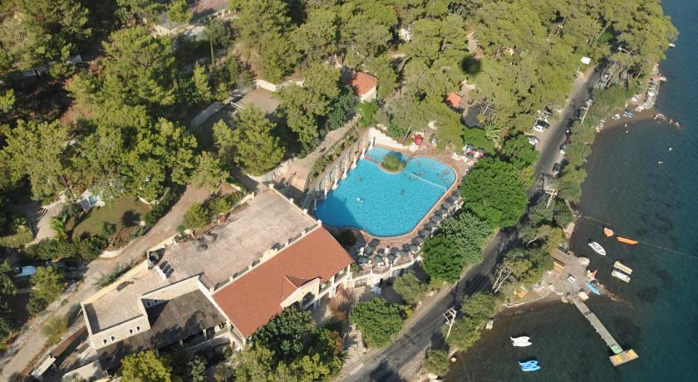

Rooms: 112 Standart Rooms
All rooms are equipped with LCD TV, 30 channels on the TV broadcasts , telephone , minibar, hair dryer , shower and balcony. All of our rooms have sea views.

Pools: Restaurants&Bars
- 1 Activity pool 350 m2, 1.40 cm deep, 1. Sun set A La carte 3. Snack; pide, pizza, burger
- 1 Child pool 20 m2, 0,40 cm deep, 2. Main Restaurant (open buffet) 4. Beach Bar

Facility; The main building ( reception and lobby area) , the restaurant building ( TV , games room and shopping area) is a compact unit with 8 standard rooms in each of the 14 separate blocks. Restaurant gives buffet. Top pool and children's pool is a large area is safe here. Alta la carte restaurant is also open for use by guests (extra).

ENTERTAINMENT:

Club Nimara Beach – Resort :
Daily activities Turkish nights Evening Activities

FOODS & BEVERAGES:

Club Nimara Beach - Resort :
Beach Bar Main Restaurant (Open Buffet) Snack Bar
Beach Club Sun set A La Carte Restaurant TV & Game Hall

FREE ( ALL-INCLUSIVE CONCEPT | PAID
Open Buffet (Main Restaurant) (Breakfast – Lunch – Dinner) | Sunset A La Carte Restaurant
Snacks (Snack Bar) (pide, pizza, burger, cips) | Turkish Coffee
Alcoholic beverages (beer, vodka, gin, rakı, whiskey) | Fresh Orange Juice
Non alcoholic beverages (coke, fanta, sprite, mineral water, fruit juices, water) | Transfer-taxi
Hot beverages (nescoffee, tea, herbal teas) | Imported Beverages
İnternet (Public areas) | Massage
Parking | Tennis lighting
Safe (odalarda) | Water sports
Beach & Pool Towel | Beach Club
Mustrus & Sunbed (Pool & Beach)
Turkish bath (specific hours)
Fitness (specific hours)
Table Tennis
Tennis

Concept ; food starts with 7:00 breakfast, 21:30 ends with dinner , beverages 10.00 - served from 23.00.

FOODS:
Breakfast | Main Restaurant | 07.00 - 10.00
Late Breakfast | Main Restaurant | 10.00 - 11.00
Lunch | Main Restaurant | 12.30 - 14.00
Coffee break | Snack Bar | 17.00 - 18.30
Snack foods | Snack Bar | 12.00 - 16.00
Dinner | Main Restaurant | 19.30 - 21.30  19.30 - 22.30
Dinner | Sunset A La Carte (paid) | 19.30 - 21.30  19.30 - 22.30

DRINKS:
Alcoholic & Non alcoholic beverages | Servis Bar (Main Restaurant) | 12.30 – 14.00 / 19.30 – 21.30
Hot beverages | Servis Bar (Main Restaurant) | 07.00 - 11.00
Hot, Soft and Alcoholic beverages | Snack Bar | 10.00 – 23.00
Soft Beverages | Beach Bar | 11.00 – 18.30
Alcoholic & Non alcoholic beverages | Beach Bar (paid) | 23.00 – 02.30

