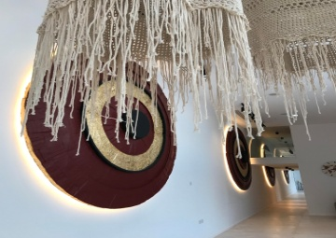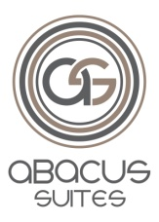

**OVERVIEW**

Abacus Suites enjoys an ideal location in the resort of Ayia Napa, in famous Nissi Avenue and just 5 minute walk from the beach.

The lively center of Ayia Napa is just few minutes’ walk, where guests are spoiled with large choices of restaurants and bars. The comfortable guestrooms, all furnished to excellent standards, combined with the relaxing atmosphere make it an ideal choice for a memorable holiday experience.

The luxury suites are well decorated with beautiful textured details and fabrics. Each suite has its own private furnished balcony.

Abacus Suites team, offers high quality service, true Cyprus Hospitality, ideal for couples and families.

**BUILDING**

Built Year: 2018

Number of Rooms: 36

Number of floors: 2

Number of elevators: 1

**LOCATION**

Situated in Nissi Avenue, just a short stroll from Ayia Napa shops and restaurants. Beach is just five minutes’ walk away.

400m to bus stop

2,3km from Nissi Beach

4,5km from WaterWorld Themed WaterPark

1,3km from Ayia Napa Harbor

850m from Ayia Napa Monastery

64,7km from Larnaca International Airport

Google Maps: 34.9877775072613,33.9915033599243

**HOTEL FACILITIES AND SERVICES**

Swimming Pool

Pool Bar  
Free Internet Wi-Fi access

Beach Towels**

Car Rental & Taxi Service*

Laundry Service (except Weekends and Holidays)*

Late Check - out Service*

Free Parking

Luggage Room

Soundproof Rooms

Daily Housekeeping

Souvenir Shop

Jewellery Shop

Convenience Store

Bank

*facilities and services at an extra charge

**deposit required

**ROOMS**

Number of rooms: 36

Number of beds: 72

Number of room types: 3

|  |  |  |  |
| --- | --- | --- | --- |
| Room Type | Available | M2 | Max Occupancy |
| Deluxe Suite | 25 | 38 | 3/ 2+2 |
| Standard Room | 8 | 27 | 2/ 2+2 |
| Family Deluxe Suite | 3 | 60 | 4/ 3+2 |

* Deluxe Suites includes sofa-bed
* Standard Rooms includes sofa-bed
* Family Deluxe Suite includes 2 bedrooms with 4 Twin Beds

**ROOM FACILITIES**

**Standard features in each room**

* Satellite Flat Screen TV
* Direct Dial Telephone
* Free Mini Fridge
* Free Digital Safety Box
* Free Wi-Fi
* Free Air Conditioning
* Hairdryer
* Tea & coffee Facilities
* Furnished Balcony
* Toiletries
* Bathroom with walk - in Shower

**RESTAURANT – CAFE – BAR:**

**SUITE34**

