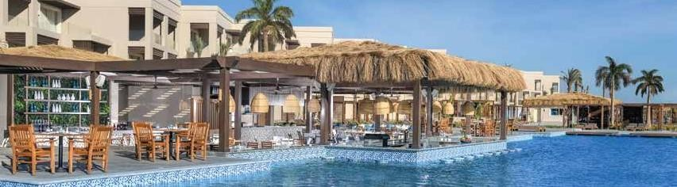

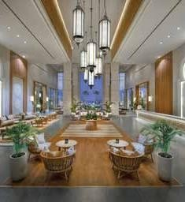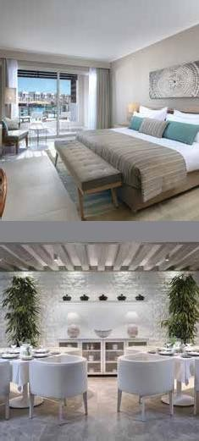

NEW LEVEL OF OPULENCE BY THE RED SEA.

# ALL INCLUSIVE

Guest will upon arrival be greeted with refreshments served from our exclusive beverage trolley, serving fruit cocktails, juices, sparkling wine and selection of macarons, nuts and chocolates etc.

The All-Inclusive concept offers guest unlimited access to all restaurants and bars. This includes the breakfast, lunch, and dinner in Kahramana Main Restaurant, as well as, the late breakfast in Cabana restaurant, afternoon tea in Safari Bar.In addition,all restaurants serve signature á la carte dinner–with prior reservation and according to availability.

The All-Inclusive package starts at the moment of arrival and ends once guests leaves the hotel, i.e. door to door.

# ROOM AMENITIES

Welcome Amenities in guest rooms

Free Wi-Fi in guestrooms, lobby and public areas

Tea & Coffee making facilities with replenish in the room

Soft minibar with soft drinks, juices, water – Refilled once daily Complimentary replenishment of water bottles in the guest rooms Beach and Pool towels available in each guest room

# ALL-INCLUSIVE BEVERAGE SELECTION

Local Premium branded spirits, Heineken draught beer and local bottled beers

Two choices of grape varieties for Red wine, White wine and Rose wine – from the premium selection of local wines

Unlimited access to fresh juices and soft drinks

Unlimited access to our premium cocktails with local premium alcohol Unlimited access to our selection of mocktails and smoothies Premium quality tea and coffee

# NOTES

All beverages are served by the glass. They will not be served in bottles. Cocktails that contain imported alcohol are subject to an additional extra charge.

# BARS

## ALL-INCLUSIVE BEVERAGE - OPERATING HOURS

Safari Lobby Bar & Lounge Cabana Pool Bar

Open 24 hours

10:00 – Sunset

## ARABESQUE LEBANESE SPECIALTY RESTAURANT

Specializing in Oriental and Lebanese authentic cuisine, with selected signature dishes from the levant. A wide range of mezza and grilled items are served to perfection.

Dinner 18:30 – 21:30h

Aqua Bar 10:00 – Sunset

Maya Beach Bar Beach Bar

# RESTAURANTS

## ALL-INCLUSIVE DINING KAHRAMANA MAIN RESTAURANT

10:00 – 21:30h

10:00 – Sunset

## DRESS CODE

The dress code at dinner for men in all restaurants is smart casual (Polo shirt/shirt/long trousers/shoes). It is not allowed to go inside any restaurant with swimming suits.

À la carte restaurants are included in the all-inclusive concept; reservation is required in advance through the Guest Relations Office. Reservations for the same day end at 17:00.

The culinary heart of the hotel, serving breakfast, lunch and dinner, offering International Mediterranean cuisine using fresh ecologically sourced ingredients, including fresh juices, tea and coffee, water and all beverage as per the all-inclusive concept.

Breakfast Buffet 07:00 – 10:30h

Lunch Buffet 12:30 – 14:30h

Food items on the à la carte menus marked with * will be charged at extra cost.

# ALL-INCLUSIVE PACKAGE

 Complimentary birthday cake or anniversary cake

Dinner Buffet

## NOTES

18:30 – 21:30h

(with 24hours prior notice)

 Preferential green fees at Madinat Makadi Golf Resort and Cascades Golf Resort nearby (with prior reservation)

Lunch buffet is available depending on hotel occupancy and is

replaced by Cabana Pool Restaurant and Maya Beach Restaurant.

## CABANA POOL-SIDE RESTAURANT & BAR

Serving à la carte lunch or dinner array from Italian and Mediterranean specialties, a sunken bar with fresh cocktails, mocktails and small nibbles.

Bar Opens 10:00 – 21:30h

Late Breakfast 10:30 – 11:30h

Lunch 12:00 – 16:30h

 Access to Madinat Makadi Water World with preferential entrance fees and transfer fees

# WELL-BEING & FITNESS

 Unlimited access to our state-of-the art fitness center open 24 hours  Yoga and Pilates with a designated instructor as per daily

schedule

 Day activities – pool games, water aerobics, beach volleyball, boccia, Zumba, step aerobics and football

Dinner

## MAYA BEACH RESTAURANT & BAR

18:30 – 21:30h

This charming venue with its mind blowing sea view serves the most savory salads, snacks and different grill items during lunch, while it turns to a pure bistro at dinner time dedicated to offering its guests the most fresh mediterrane cuisine a la carte plates in an ambiance of refinement.

.Bar Opens 10:00 – 21:30h

Lunch 12:00 – 16:30h

Dinner 18:30 – 21:30h

## BENISUMA JAPANESE & ASIAN SPECIALTY RESTAURANT

Offering a carefully and perfectly balanced selection of Asian specialties ranging from Japanese Sushi and Sashimi as well as authentically prepared Thai & Indonesian dishes.

Dinner 18:30 – 21:30h

## NOTE

Teppanyaki items and set menus are subject to an additional extra charge.

Steigenberger Resort Ras Soma

Safaga Road, 55 KM, P.O. Box 84911, Ras Soma, Safaga, Red Sea, Egypt

**T** +20 65 3257 500, **E** [reservations.ras-soma@steigenberger.com,](mailto:reservations.ras-soma@steigenberger.com) hrewards.com

# KIDS LAND

 Full day children activity program at “Kids Land” club for all ages including indoor program, learning and crafts room, games room, special toys, playground and sleeping rooms, supervised by professional attendants

 Games area – table tennis, baby foot and darts

 Daily “mini-disco” for all children – kids dance, magic shows and kids show

# ENTERTAINMENT & LIVE SHOWS

 Daily live music in Safari bar

 Daily live evening entertainment program with international shows