Martiness Apartments 3*, Durres

- 22 rooms
- Room Size 32 m2
- 200 m to the beach
- the pool is included, and breakfast consumed in the hotel's restaurant
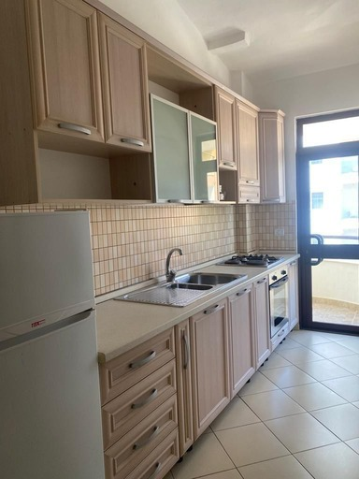
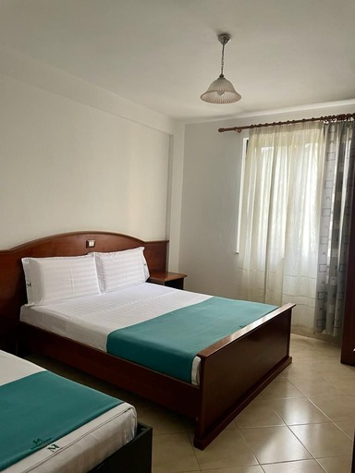
Apartment with kitchen for 4 person. Size 48 m2.
Double bed 180*200 and 2 single beds 90*200.
The apartment is equipped with a kitchen, stove, refrigerator and all the basic equipment for cooking. They do not have a kettle and a safe box. They have free access to wifi, uncovered parking, free access to the pool and are monitored 24 hours by cameras for safety and security.
2 large towels and 2 small towels are provided. Cleaning is performed only on the day of check in and check out.

Apartment typology for 3 people - no kitchen.
1 Double bed 180*200 and 1 single bed 90*200.
They do not have a kettle or safe box. They have free access to wifi, uncovered parking, free access to the pool and are monitored 24 hours by cameras for safe and security. There are 2 large towels and 2 small towels. Cleaning is performed only on the day of check in and check out.

