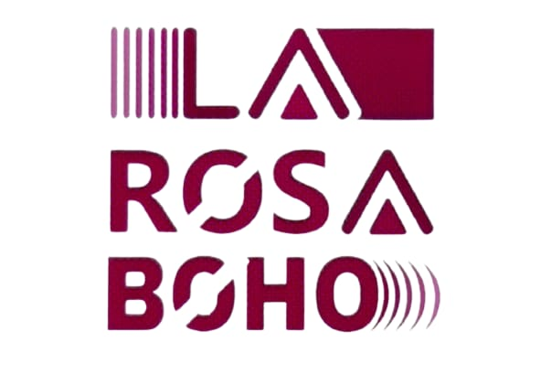

La Rosa Boho “ALL INCLUSIVE” CONCEPT

**DEAR GUESTS KINDLY PAY ATTENTION THAT AT THE SUNRISE AND SUNSET TIME IT WOULD BE WORKED DESINFACTION TEAM ON ALL THE TERRITORY TO AVVOIED THE INSECTS ISSUE**

# Breakfast

Served at the **Main Restaurant**

**From 07:00 till 10**:**00**

# Late Breakfast

**Tika Zone**

**From 10:00 till 11:00**

# Snacks

**Tika Zone**

**From 12:00 till 13:00**

# Lunch

Lunch is served at the following outlets

**Main restaurant from 13:00 Till 15:00**

**(Clothing restrictions: It is forbidden to come in beachwear)**

# Sweets

**Tika Zone**

**From 16:00 to 17:00**

# Dinner

Dinner is served at the following outlets

**Main restaurant from 19:00 Till 21:00**

**(Clothing restrictions: It is forbidden to come in beachwear)**

It includes international buffet with live cooking and carving station, soft drinks, local wines, Local spirits and local beer, coffee and tea



**Mini Bar in the room**

Mineral Water; 1 bottle per person is refilled daily

**Tea & Coffee Tray**

Available at all rooms – Kettle and cups (Tea, Nescafe, Sugar)

Beverages served at:

|  |  |  |
| --- | --- | --- |
| **Bar** | **Boho Bar (Located at main Restaurant)** | **10:00 till 23:00** |
| **Bar** | **Tika Zone Bar (located at Pool Bar)** | **10:00 till Sunset** |
| **Bar** | **Lounge bar (located at Reception)** | **10:00 till 23:00** |

Mineral water, soft drinks and local alcohol (excluding fresh fruit juices and Turkish coffee).

Room Service 24 Hours (Against Charge)

Local wine will be served at the main Restaurant during Lunch & Dinner.

Lounge Bar working from 10:00 till 23:00 free of charge.

A’la carte restaurant “Tika” for dinner reservation with Guest Relation or Restaurant Manager (all inclusive)

Kids club from 10:00 to 12:30 and from 15:00 to 17:00

**Entertainment:**

Daily international animation program on the information board

**SPORTS:**

Darts and Billiard table are free of charge with the animation team.

**\*All those activities are part of the daily leisure program, please check the time.**

**\*\*During specified times activities are free.**

IMPORTANT INFORMATION:

In order to enjoy the “All Inclusive” services the all-inclusive bracelet must be on at all times during the stay. It is forbidden to bring any food from outside to the hotel.

In case of loss the room Key a charge of 5 $ or 5 Euro will be charged to you. In case of loss the towel card or beach towel it charged 300 LE. For your comfort on the beach, we have a red flag at the towel station free, to avoid any disturbing during relaxing. It’s forbidden to make the reservation on the sun beds and do not use it. If the sun bed with the towel on it have no guests more than 15 minutes, towels would be removed by the recreation staff.

It is not allowed to take any food or beverages outside the restaurants, if you have any special requirements please contact with the F&B Manager.

The time of check-out is 12:00 noon. After 12:00 all services, including food & beverage, should be paid in cash.

Cash or credit card payments are not accepted at all hotel outlets during the stay. The hotel checks need to be signed to room account and will need to be settled at the reception desk during or at the end of stay.

The hotel outlets will only accept the cash or credit card payments after check out as the room bill is closed.